October 7, 2012

Dear Patrons of the Blessed Margaret of Castello Guild and Shrine,

May God bless you and pour upon you a double portion of the spirit of Little Margaret! As I finish this letter on the Feast of Our Lady of the Rosary, my prayer for you is that you always rejoice in the protection and maternal love of our Lady, to whom Blessed Margaret turned for help and rejoiced in our Blessed Mother’s love.

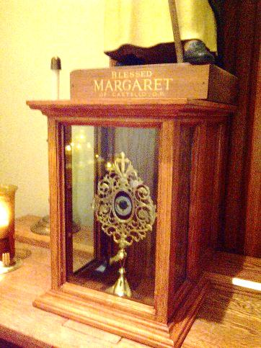
Allow me to report on Bl. Margaret’s activity locally, nationally and globally. I shall begin with the recent enhancements at her Shrine before addressing the approaching elections and the current status of Blessed Margaret’s cause for canonization. Finally, I shall explain how you can help in these endeavors.

The Shrine of Bl. Margaret was recently fitted with a new reliquary to house the Shrine’s relic of the incorrupt heart of Little Margaret. Too many people visited the Shrine without noticing the nearby reliquary case with this priceless treasure in the midst of other holy relics. Now she will not be overlooked. At the feet of the statue of Blessed Margaret of Castello, this relic of her loving heart is prominently displayed for veneration. If ever you are in Columbus, please do not miss the opportunity to drive to downtown Columbus to visit the Shrine and pay your respects to our dear Little Margaret.

As members of the Blessed Margaret of Castello Guild, we entrust those deemed as “unwanted” to the powerful prayers of our dear patroness, who knew well what it meant to be undesirable when her own parents hid her, imprisoned her and abandoned her. As the United States of America faces another election, please join me, the Dominican Friars, and the other members of the Guild in praying daily for Little Margaret’s intercession for divinely providential results that will increase the respect for all life, including the “unwanted” members of society, especially threatened babies still in their mothers’ wombs. Dear Blessed Margaret, hear our prayers!

Fr. Francesco Ricci, O.P., the Promoter for Dominican Saints in Rome who is responsible for pursuing Bl. Margaret’s cause for canonization, has completed the bulk of the work necessary for Little Margaret’s canonization. Everything is documented and prepared for the final brief to be presented to the Congregation for the Causes of Saints, except for a recent miracle. Confident that God awaits a providential moment to grace us with this miracle, the Guild is ready to provide Fr. Ricci our financial support when the time comes for the final processing of Bl. Margaret’s cause.
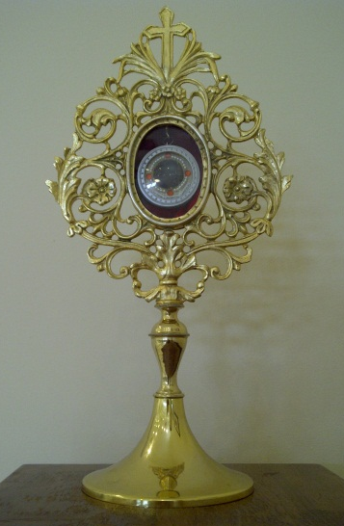
One more miracle. That is all it takes. History attests to so many miracles over the centuries attributed to Bl. Margaret. All of us in the Guild have surely experienced her powerful intercession. Surely God will deign to provide a miracle through Bl. Margaret when the world needs to know the value of every life. At the same time, God also wants us to recognize the value our prayers in their role in His providential plans. Please pray, therefore, that Bl. Margaret’s canonization receives the miracle needed. So often I receive reports of miracles, but a suitable miracle has to be truly wondrous, incapable of a natural explanation, solely and verifiably entrusted to the saint’s intercession, and accurately documented with all the appropriate medical records and multiple attestations. If you know of a miracle attributed exclusively to the intercession of Blessed Margaret, document everything and contact me. Meanwhile, please continue to pray that God blesses us with a miracle in honor of Little Margaret!
The Shrine’s Relic from Bl. Margaret’s incorrupt heart

As the director of the Shrine, it is my annual responsibility to address you and the rest of the Guild to plea for your generous donations for the works of the Blessed Margaret of Castello Shrine. Today I am once again asking you to join in the work of the Shrine, the promotion of life, and the canonization of our beloved Little Margaret by your generosity. Our annual Charity Appeal letter also comes with a blank form for you to send us the names of family and friends who may want to obtain information on Blessed Margaret. (Please know that if you provide us with someone’s name we will send information only once, and will not add him or her to our mailing list until they ask us to do so.) Also if you would like to place your intentions directly on the altar shrine of Blessed Margaret, please fill out the enclosed form and send it to us, with or without a contribution. Thank you for your generous prayers and any other support you can give.

Thank you for your continued support and prayers. Please know that you and your families and friends are in my prayers. May our God who is never outdone in generosity bless you abundantly, and may you experience the mighty prayers of Little Margaret now and forever.

God bless you!

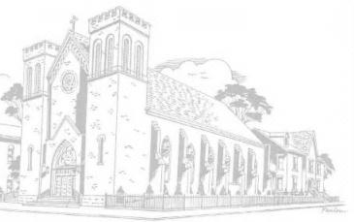
In our Lord, our Lady, and Blessed Margaret,
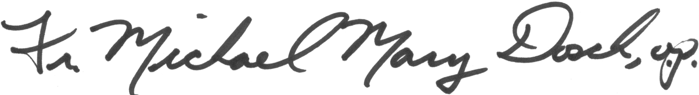
Rev. Michael Mary Dosch, O.P.
Shrine and Guild Director
St. Patrick’s Church and Shrine to Bl. Margaret
Columbus, Ohio

