March 2012

Dear Friends of Blessed Margaret,

Happy 725th birthday, Little Margaret! This year marks seven-and-a-quarter centuries since our beloved Blessed Margaret was born to her parents and rejected by them. Although her birth was greeted with indignation, her birth into eternal life on April 13 at the age of thirty-three was dignified by her first postmortem miracle of a crippled girl cured at Margaret’s funeral. The miracles through her intercession have never stopped.

As director of the Bl. Margaret Guild and Shrine, I receive numerous calls from those attributing some miraculous event to the intercession of Bl. Margaret. Recently, I was excited to hear of a healing that was truly miraculous – a child born without kneecaps who then had them – but even though medical testimony was promising, the invocation of another saintly person’s intercession excludes it from being the miracle.

We simply await a miracle that meets all the Church’s requirements and signifies that it is time to raise Bl. Margaret to the honors of sainthood within God’s providential timing. Allow me to recap the progress of her canonization.

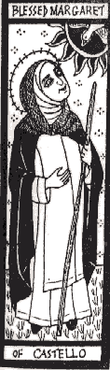
After nearly three centuries of devotion to the saintly woman, Pope Paul V beatified Margaret on October 19, 1609. Nearly four centuries later, in 1999 a canonical recognition of the body of Blessed Margaret took place, at which time small fragments from her incorrupt body enshrined under the main altar in the Church of St. Domenico at Città di Castello, Italy, were taken in order to prepare relics, including the relic of her incorrupt heart here at the Shrine. Her biography was published shortly thereafter in several languages. In 2003, the Dominican Curia then began an aggressive campaign to raise funds to help defray the expenses of the cause, to which the Guild raised over $10,000, about a quarter of the cost. According to Fr. Francesco Ricci, O.P., Promoter for Dominican Saints in Rome, all the paperwork and procedures are complete, except one. Bl. Margaret’s cause simply requires an approved miracle before the final case can be presented to the Congregation for the Causes of Saints.

An approved miracle has to be truly wondrous, incapable of a natural explanation, solely and verifiably entrusted to the saint’s intercession, and accurately documented with all the appropriate medical records and multiple attestations. If you know of a miracle attributed exclusively to the intercession of our little saintly woman of Castello, please document everything and contact the Guild.

Most importantly, please pray for Bl. Margaret’s canonization. It was the insistence of the people of the Città di Castello at the funeral, imploring the Friars to bury her in the church, that God acknowledged her holiness by the miraculous healing of a young crippled girl. May the Lord hear our fervent requests for Blessed Margaret’s recognition and grant a miracle that meets all the conditions necessary for her canonization.

Does not our tumultuous world, which designates so many lives as “unwanted,” desperately need her saintly example? Now is the time to respond in prayer that God may raise Bl. Margaret to the honor of sainthood as a testimony to the world of the great value of every life! God deigns to attribute great value to our prayers such that there are many things that He will do only with our prayers. Please pray for this cause so urgently needed today.

I also invite you to participate in spreading devotion to Bl. Margaret and ask others to join in this petition. You may use the enclosed form to let them know about the Guild, but it is more important that you suggest to those in need to seek her powerful intercession.

Ceaseless have been the miracles at her intercession. Your intentions are included in the special nine-day Novena of Masses in Bl. Margaret’s honor, beginning on her feast day, April 13. (The Novena usually begins March 5 and ends on the feast day, but it will begin on her feast this year because of the timing of Easter.) Please find the enclosed request form and return envelope if you wish to add your specific intentions to be placed in her Shrine during the Blessed Margaret Novena of Masses.

Finally, I would like to thank you for your prayers and support for the work of the Guild and Shrine of Blessed Margaret of Castello. Please know that you and your intentions are in my prayers. I would also like to thank you in advance for your financial support which will help defend the dignity of life through the various charities of the Guild as well as support Bl. Margaret’s cause for canonization. May God bless you during this holy season of Lent and grant your requests from the prayers of Little Margaret!

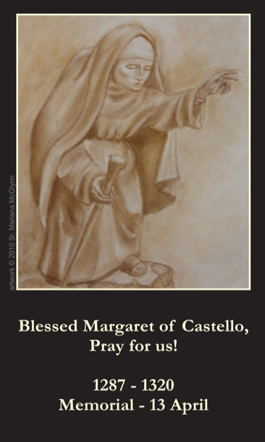
O God, you filled blessed Margaret with a divine inner light to contemplate you alone, and enlightened the eyes of her heart, although she was blind; be our light as well, by which we may be able to avoid the darkness of this world and come to the land of eternal brightness.

In our Lord, our Lady, and Blessed Margaret,
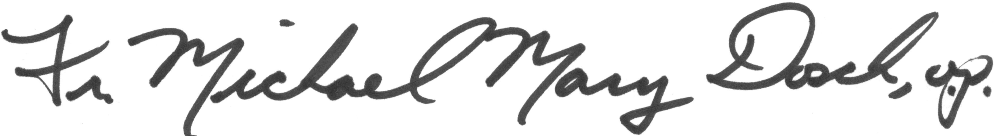
Rev. Michael Mary Dosch, O.P.
Shrine and Guild Director

