March 2011

Dear Friends of Blessed Margaret,

From the Città di Castello, I send my blessing! On February 16, I offered the Holy Sacrifice of the Mass for you and the members of the Guild at the altar containing the incorrupt body of our beloved Little Margaret.

I have news to report. While attending the national directors meetings in Lourdes, France, I took the opportunity to visit the Promoter for Dominican Saints in Rome and made a personal pilgrimage to the Città di Castello.

Fr. Francesco Ricci, O.P., is responsible for promoting Blessed Margaret’s cause for canonization. We had a delightful meeting at Santa Sabina, the Dominican headquarters on the Aventine hill of Rome overlooking St. Peter’s Basilica. Fr. Francesco explained to me how the majority of the work for Little Margaret’s canonization is complete. All the paperwork and procedures that he can do has been done – which is quite a lot – but only one thing stands in the way before the final case can be presented to the Congregation for the Causes of Saints… a miracle.

Bl. Margaret’s cause simply requires an approved miracle. Here at the Shrine of Blessed Margaret in Columbus, I receive reports of miracles all the time. However, an approved miracle has to be truly wondrous, incapable of a natural explanation, solely and verifiably entrusted to the saint’s intercession, and accurately documented with all the appropriate medical records and multiple attestations. There are often miracles that do not meet these requirements. I have personally seen an instantaneous miracle occur in Lourdes, but the medical doctors were uncooperative with being able to pursue the miracle’s legitimacy. Therefore, if you know of a miracle attributed exclusively to the intercession of our little saint of Castello, document everything!

Please pray for Bl. Margaret’s canonization. The world desperately needs her saintly example in its present condition with so many lives labeled as “unwanted.” There are many things that God will only do with our cooperation – that is the great value of prayer. We are invited to participate in the elevation of Bl. Margaret to the honor of sainthood by our prayers and the spreading of devotion to her. It is also my plan that when the miracle comes to light, that our Guild will be poised to aid Fr. Franceso financially with the final steps of submitting her case to the Congregation for the Causes of Saints. Please pray for this saint so needed by the world. Dear Blessed Margaret, patroness of the unwanted, pray for us!
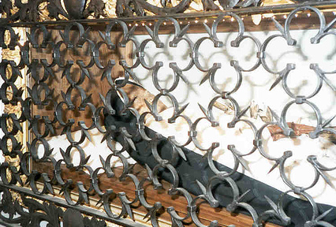
After making the drive from Rome to the Città di Castello, it was such a joy to enter the Church of Saint Dominic (the picture on the left) where lies the body of our Little Margaret! I immediately lit a candle for all of you, the intentions of all the members of the Guild, and for the canonization of Blessed Margaret. She was beautiful to behold, even though her deformities are still apparent and her incorrupt state is a dark complexion. You cannot look upon her without being moved by the hard realities of her life juxtaposed with the Lord’s tenderness for his dear daughter manifested by the miraculous honor of incorruption. I experienced both peace and joy while praying there, which was only surpassed the next morning when I offered Mass for you at the altar constructed over her relics!

I also prayed for you at the Chiesa San Francesco in which lies the tomb of Fra Giacomo where Bl. Margaret was abandoned by her parents. The convent, abandoned now and which most recently had been a school for the blind, had the life of Bl. Margaret displayed in frescos painted in thirty-two arches in the courtyard, all in various stages of disrepair. One that I particularly liked was the veneration of her body at her death, a picture of which is at the top of this page. Thus begins the posthumous devotion to her and the many miracles flowing from her intercession!

I would like to thank you for your prayers and support for the work of the Shrine of Blessed Margaret of Castello. Please know that you and your families and friends are in my prayers. Please find the enclosed request form and return envelope if you wish to add your specific intentions to the special nine-day Novena of Masses in Bl. Margaret’s honor beginning on April 5th. I would also like to thank you in advance for your financial support which will help defend the dignity of life through the various charities of the Guild as well as support Bl. Margaret’s cause for canonization. May God bless you during this holy season of Lent and grant your requests from the prayers of Little Margaret!

In our Lord, our Lady, and Blessed Margaret,
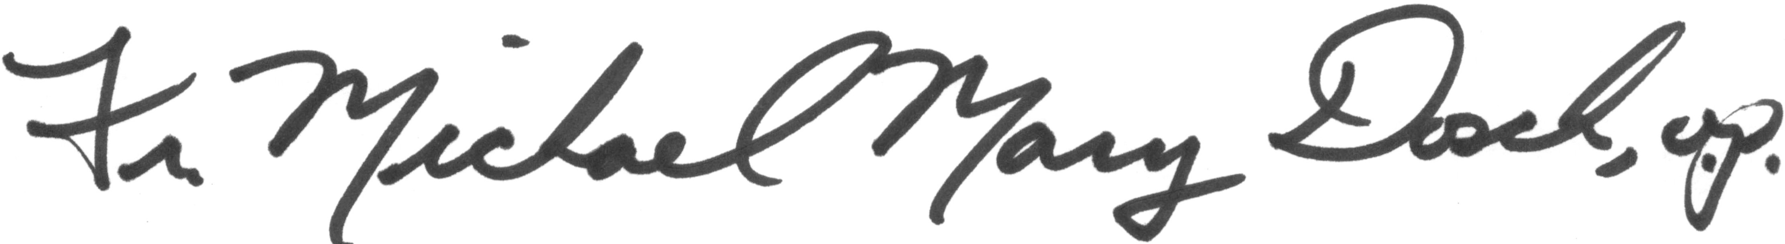
Rev. Michael Mary Dosch, O.P.
Shrine and Guild Director

